**Creating final data for crop and fertilizer recommendation system**

In [1]:

**import** pandas **as** pd

**import** matplotlib.pyplot **as** plt

**import** seaborn **as** sns

In [2]:

fertilizer_data_path **=** '../Data-raw/FertilizerData.csv'

merge_fert **=** pd**.**read_csv(fertilizer_data_path)

In [3]:

merge_fert**.**head()

Out[3]:

|  | **Unnamed: 0** | **Crop** | **N** | **P** | **K** | **pH** |
| --- | --- | --- | --- | --- | --- | --- |
| **0** | 0 | rice | 80 | 40 | 40 | 5.5 |
| **1** | 3 | maize | 80 | 40 | 20 | 5.5 |
| **2** | 5 | chickpea | 40 | 60 | 80 | 5.5 |
| **3** | 12 | kidneybeans | 20 | 60 | 20 | 5.5 |
| **4** | 13 | pigeonpeas | 20 | 60 | 20 | 5.5 |

In [4]:

**del** merge_fert['Unnamed: 0']

In [5]:

merge_fert**.**describe()

Out[5]:

|  | **N** | **P** | **K** | **pH** |
| --- | --- | --- | --- | --- |
| **count** | 22.000000 | 22.000000 | 22.000000 | 22.000000 |
| **mean** | 50.454545 | 45.681818 | 48.181818 | 5.409091 |
| **std** | 36.315715 | 32.634172 | 51.698426 | 0.590326 |
| **min** | 20.000000 | 10.000000 | 10.000000 | 4.000000 |
| **25%** | 20.000000 | 20.000000 | 20.000000 | 5.500000 |
| **50%** | 30.000000 | 40.000000 | 30.000000 | 5.500000 |
| **75%** | 80.000000 | 60.000000 | 50.000000 | 5.500000 |
| **max** | 120.000000 | 125.000000 | 200.000000 | 6.500000 |

In [6]:

merge_fert['Crop']**.**unique()

Out[6]:

array(['rice', 'maize', 'chickpea', 'kidneybeans', 'pigeonpeas',

'mothbeans', 'mungbean', 'blackgram', 'lentil', 'pomegranate',

'banana', 'mango', 'grapes', 'watermelon', 'muskmelon', 'apple',

'orange', 'papaya', 'coconut', 'cotton', 'jute', 'coffee'],

dtype=object)

In [7]:

plt**.**plot(merge_fert["N"])

Out[7]:

[]

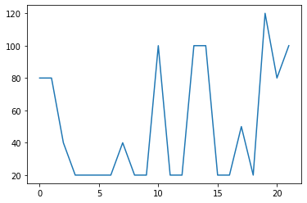

In [8]:

plt**.**plot(merge_fert["P"])

Out[8]:

[]

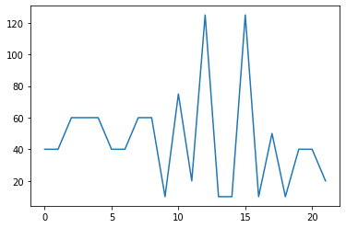

In [9]:

plt**.**plot(merge_fert["K"])

Out[9]:

[]

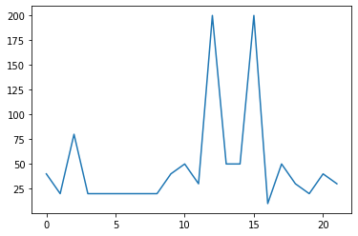

In [10]:

sns**.**heatmap(merge_fert**.**corr(),annot**=True**)

Out[10]:

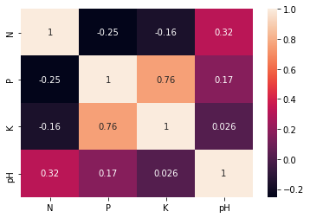

In [11]:

merge_crop **=** pd**.**read_csv('../Data-raw/MergeFileCrop.csv')

reco_fert **=** merge_fert

In [12]:

*#Add +/-3 for every NPK value*

**import** random

temp **=** pd**.**DataFrame(columns **=** ['N','P','K'])

**for** i **in** range(0,merge_crop**.**shape[0]):

crop **=** merge_crop**.**label**.**iloc[i]

*#print(crop)*

N **=** reco_fert[reco_fert['Crop'] **==** crop]["N"]**.**iloc[0] **+** random**.**randint(**-**20,20)

P **=** reco_fert[reco_fert['Crop'] **==** crop]["P"]**.**iloc[0] **+** random**.**randint(**-**5,20)

K **=** reco_fert[reco_fert['Crop'] **==** crop]["K"]**.**iloc[0] **+** random**.**randint(**-**5,5)

d **=** {"N":N,"P":P,"K":K}

*#print(d)*

temp **=** temp**.**append(d,ignore_index **=** **True**)

In [13]:

temp

Out[13]:

|  | **N** | **P** | **K** |
| --- | --- | --- | --- |
| **0** | 90 | 42 | 43 |
| **1** | 85 | 58 | 41 |
| **2** | 60 | 55 | 44 |
| **3** | 74 | 35 | 40 |
| **4** | 78 | 42 | 42 |
| **...** | ... | ... | ... |
| **2195** | 107 | 34 | 32 |
| **2196** | 99 | 15 | 27 |
| **2197** | 118 | 33 | 30 |
| **2198** | 117 | 32 | 34 |
| **2199** | 104 | 18 | 30 |

2200 rows × 3 columns

In [14]:

merge_crop['N'] **=** temp['N']

merge_crop['P'] **=** temp['P']

merge_crop['K'] **=** temp['K']

In [15]:

merge_crop

Out[15]:

|  | **Unnamed: 0** | **temperature** | **humidity** | **ph** | **rainfall** | **label** | **N** | **P** | **K** |
| --- | --- | --- | --- | --- | --- | --- | --- | --- | --- |
| **0** | 0 | 20.879744 | 82.002744 | 6.502985 | 202.935536 | rice | 90 | 42 | 43 |
| **1** | 1 | 21.770462 | 80.319644 | 7.038096 | 226.655537 | rice | 85 | 58 | 41 |
| **2** | 2 | 23.004459 | 82.320763 | 7.840207 | 263.964248 | rice | 60 | 55 | 44 |
| **3** | 3 | 26.491096 | 80.158363 | 6.980401 | 242.864034 | rice | 74 | 35 | 40 |
| **4** | 4 | 20.130175 | 81.604873 | 7.628473 | 262.717340 | rice | 78 | 42 | 42 |
| **...** | ... | ... | ... | ... | ... | ... | ... | ... | ... |
| **2195** | 895 | 26.774637 | 66.413269 | 6.780064 | 177.774507 | coffee | 107 | 34 | 32 |
| **2196** | 896 | 27.417112 | 56.636362 | 6.086922 | 127.924610 | coffee | 99 | 15 | 27 |
| **2197** | 897 | 24.131797 | 67.225123 | 6.362608 | 173.322839 | coffee | 118 | 33 | 30 |
| **2198** | 898 | 26.272418 | 52.127394 | 6.758793 | 127.175293 | coffee | 117 | 32 | 34 |
| **2199** | 899 | 23.603016 | 60.396475 | 6.779833 | 140.937041 | coffee | 104 | 18 | 30 |

2200 rows × 9 columns

In [16]:

**del** merge_crop['Unnamed: 0']

In [17]:

merge_crop

Out[17]:

|  | **temperature** | **humidity** | **ph** | **rainfall** | **label** | **N** | **P** | **K** |
| --- | --- | --- | --- | --- | --- | --- | --- | --- |
| **0** | 20.879744 | 82.002744 | 6.502985 | 202.935536 | rice | 90 | 42 | 43 |
| **1** | 21.770462 | 80.319644 | 7.038096 | 226.655537 | rice | 85 | 58 | 41 |
| **2** | 23.004459 | 82.320763 | 7.840207 | 263.964248 | rice | 60 | 55 | 44 |
| **3** | 26.491096 | 80.158363 | 6.980401 | 242.864034 | rice | 74 | 35 | 40 |
| **4** | 20.130175 | 81.604873 | 7.628473 | 262.717340 | rice | 78 | 42 | 42 |
| **...** | ... | ... | ... | ... | ... | ... | ... | ... |
| **2195** | 26.774637 | 66.413269 | 6.780064 | 177.774507 | coffee | 107 | 34 | 32 |
| **2196** | 27.417112 | 56.636362 | 6.086922 | 127.924610 | coffee | 99 | 15 | 27 |
| **2197** | 24.131797 | 67.225123 | 6.362608 | 173.322839 | coffee | 118 | 33 | 30 |
| **2198** | 26.272418 | 52.127394 | 6.758793 | 127.175293 | coffee | 117 | 32 | 34 |
| **2199** | 23.603016 | 60.396475 | 6.779833 | 140.937041 | coffee | 104 | 18 | 30 |

2200 rows × 8 columns

In [18]:

merge_crop **=** merge_crop[[ 'N', 'P', 'K','temperature', 'humidity', 'ph', 'rainfall', 'label']]

In [19]:

merge_crop**.**to_csv("../Data-processed/crop_recommendation.csv",index**=False**)

In [20]:

*# Checking if everything went fine*

df **=** pd**.**read_csv('../Data-processed/crop_recommendation.csv')

In [21]:

df**.**head()

Out[21]:

|  | **N** | **P** | **K** | **temperature** | **humidity** | **ph** | **rainfall** | **label** |
| --- | --- | --- | --- | --- | --- | --- | --- | --- |
| **0** | 90 | 42 | 43 | 20.879744 | 82.002744 | 6.502985 | 202.935536 | rice |
| **1** | 85 | 58 | 41 | 21.770462 | 80.319644 | 7.038096 | 226.655537 | rice |
| **2** | 60 | 55 | 44 | 23.004459 | 82.320763 | 7.840207 | 263.964248 | rice |
| **3** | 74 | 35 | 40 | 26.491096 | 80.158363 | 6.980401 | 242.864034 | rice |
| **4** | 78 | 42 | 42 | 20.130175 | 81.604873 | 7.628473 | 262.717340 | rice |

In [22]:

df**.**shape

Out[22]:

(2200, 8)